A Cross-Event Rating for Speedcubing on the Elo Scale
Oct 16, 2026 · @Konstantin

Abstract
We construct a composite rating for competitors in the 17 events of the World Cube Association (WCA). Each personal best is expressed as the logit, in Elo units of 400 points per tenfold odds, of the share of the 3x3 field it beats; results in the other 16 events are first placed on the 3x3 field by kernel-smoothed equipercentile linking through competitors who hold results in both events. Event ratings are combined by a log-sum-exp with constant 400, under which a competitor's overall odds equal the sum of the event odds. The rating is a normative composite indicator of career-best standing, built to satisfy five explicit criteria, one of which is that it can be recomputed within minutes of new results. In 2.09 million pairwise finishing orders from 2025–26 rounds, event-rating differences computed from earlier results fit a pooled logistic scale of 374 points per tenfold odds, but the scale differs significantly between events (235–844). Linking reaches the conventional correlation for a concordance in only one of 16 events, so the placement of events relative to each other is a convention, documented by diagnostics and sensitivity analyses. As a predictor of ratings in events entered later, the composite ranks below the mean and the best event rating. On the export of 14 October 2026, 293,518 competitors are rated; the median is 1346 and the maximum 3524.
Keywords: rating systems; composite indicators; equipercentile linking; kernel equating; Elo rating; paired comparisons; speedcubing

1 Introduction
The WCA sanctions competitions in 17 events, from the 3x3 cube, which the fastest competitors solve in under four seconds on average, to multi-cube blindfolded attempts of up to an hour. Each event has its own world ranking. There is no official measure across events, and two community metrics fill that role:
- Sum of Ranks adds a competitor's world ranks over the events; a missing event is charged the field size plus one (cuberoot.me n.d.).
- Kinch averages 100 × WR/PB over the events, counting a missing event as zero (speedsolving.com n.d.). Its original definition uses averages for most events, singles for 4BLD, 5BLD and MBLD, and the better of single and average for 3BLD and FMC.
Both metrics fix the relative weight of events implicitly. A rank counts the same in the 3x3 field of 282,266 competitors as in the 5BLD field of 1,144, and a ratio to the world record depends on how dispersed results are in each event. Chess ratings use a different unit: in the Elo system a rating difference D corresponds to an expected score of 1/(1 + 10^(−D/400)), so that 400 points correspond to odds of 10 to 1 (Elo 1978; Glickman 1999). Cubing results are not head-to-head, but every personal best can be compared with every other personal best in the same event, and the share of comparisons it wins can be expressed in the same unit. This gives each event a scale with a stated meaning. It does not by itself make different events comparable, and Section 3 states which parts of the construction are measurement and which are convention.
The paper is organized around four design questions, each answered in one subsection of Section 3: how a result is placed on an event scale (3.1), how the 17 event scales are placed on one common scale (3.2), how event ratings are combined (3.3), and how ratings stay comparable as the field grows (3.4). Section 4 checks the construction against data it did not use: finishing orders in later rounds, ratings in events entered later, the effect of each design choice, and a latent-trait model that uses all events at once. Section 5 reports the ratings with their uncertainty, Section 6 describes how the rating responds to improvement, breadth, field growth and the removal of an event, and Section 7 discusses what the rating measures, its incentives, its computational cost and its limitations. Figure 1 shows how the construction steps and the checks connect.
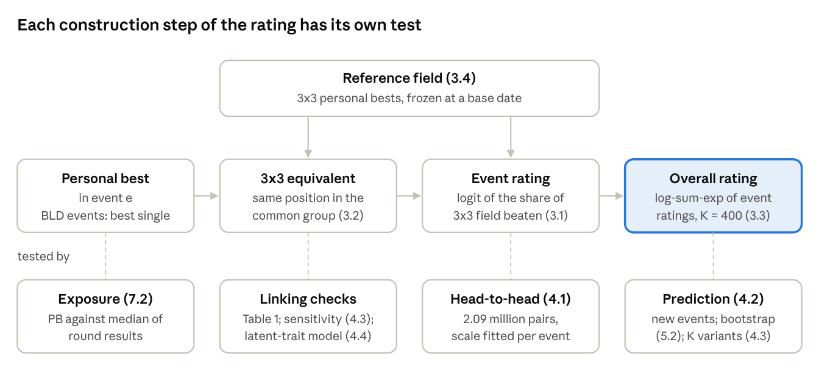
Figure 1. Construction steps of the rating (Section 3, top two rows) and the analyses that check each step (bottom row).

1.1 Estimand and criteria
The rating is not an estimator of a latent ability. It is a composite indicator (OECD and JRC 2008): a deterministic function of a competitor's personal bests, constructed to meet explicit criteria rather than to estimate the parameter of a model. Its target is a competitor's career-best standing in the events they have entered, expressed on one odds scale. The criteria are:
- Event scale. Within an event, a rating is a monotone function of the share of a reference field that the result beats, with a stated unit.
- Common scale. Events are placed on one reference field by a documented rule, and the strength of that rule is reported for each event.
- Aggregation. A higher event rating never lowers the overall rating, entering an event never lowers it, and the overall rating does not depend on the arbitrary origin of the scale.
- Stability. A competitor's rating does not change while their own results do not, except at announced renewals of the reference field.
- Feasibility. Ratings can be updated from the WCA results database within minutes of new results being posted, and recomputed in full within an hour on one server.
Criteria 1–4 decide the construction in Section 3. Criterion 5 bounds how elaborate any part of it may become, including the extensions considered in Sections 4 and 7: a component that cannot be evaluated within these limits is used only for validation, not in the rating. Predictive accuracy for unseen events is not among the criteria; Section 4.2 reports it as an external comparison.

1.2 Related work
Combining results across disciplines has a long history in sport. Decathlon and heptathlon results are summed after conversion through event-specific points tables (IAAF 2001); Woolf, Ansley and Bidgood (2007) study how the decathlon events group statistically, and Schütz and Tofallis (2024) propose a multiplicative scoring based on efficient frontiers. Stefani (1997) surveys the rating systems of major sports. Composite indicators in social statistics face the same choices of normalization, weighting and aggregation, and are assessed by sensitivity and uncertainty analysis (OECD and JRC 2008).
Paired-comparison models estimate strength from head-to-head outcomes: Bradley and Terry (1952), Luce (1959) and Elo (1978), with dynamic extensions such as Glicko (Glickman 1999) and TrueSkill (Herbrich, Minka and Graepel 2007). Plackett–Luce models extend them to complete finishing orders of many competitors (Plackett 1975; Hunter 2004), and the Universal Rating System of the Grand Chess Tour combines classical, rapid and blitz results into one list (Grand Chess Tour 2017). Latent-variable models place several observed scores on one latent scale through loadings estimated from all of them (Bartholomew, Knott and Moustaki 2011).
Placing scores from different tests on one scale is the subject of test equating and linking (Holland and Dorans 2006; Kolen and Brennan 2014). Dorans (2004) distinguishes equating, concordance and weaker forms of linking by the strength of association between the scores, and Dorans and Holland (2000) use population invariance as a test of equatability. Kernel equating continuizes score distributions with a Gaussian kernel before the equipercentile step (von Davier, Holland and Thayer 2004). That translation-invariant quasi-arithmetic means are exponential is classical (Hardy, Littlewood and Pólya 1934, ch. III; Aczél 1966), building on Kolmogorov (1930), Nagumo (1930) and de Finetti (1931). Statistical work on speedcubing is limited: Krakauer, Kardeş and Grochow (2025) study collective improvement in cube solving, and Saito (2025) models placement probabilities within a competition from solve-time distributions.

2 Data
This section defines the two data sets: the personal bests from which the rating is built, and the round results that are held back for validation.
We use the WCA results export, format version 2.0.2, of 14 October 2026 (WCA 2026a). It was read through a static mirror that republishes the export as JSON files (Ingelbrecht 2026), at commit 7e0374bc of 14 October 2026; the mirror's metadata records the export date and format version of the official export. This information is based on competition results owned and maintained by the World Cube Association, published at https://www.worldcubeassociation.org/export/results as of 14 October 2026. The export contains every official result since 1982.
Two data sets are derived from the export:
- Personal bests. For each competitor and event, the best average (the best mean of three for 6x6, 7x7 and FMC), and the best single for 3BLD, 4BLD, 5BLD and MBLD. The blindfolded events enter by single because the WCA ranks them by single and because an average requires three successful attempts in one round, which only a minority of blindfolded solvers achieve (Section 4.3 rates them by average instead). An MBLD result is scored as m = (solved − missed) + (3600 − t)/3600, its points plus the unused share of the hour with t in seconds, and enters as 1/m so that smaller is better, like a time. Because the event scale depends on a result only through its position in a distribution (Section 3.1), any increasing transformation of this score gives the same ratings up to the smoothing of Section 3.2. 293,518 competitors hold at least one personal best. This set alone defines the rating.
- Round results. Every round result with its competition, year, round and finishing position: 6,931,594 results from 17,943 competitions held between 1982 and 2026. Of these, 1,784,468 results from 61,115 rounds in 4,812 competitions fall in 2025–26. This set is used only for validation (Section 4) and to measure how personal bests depend on the number of rounds entered (Section 7.2).
The 3x3 field of N = 282,266 competitors is the reference population: every event rating is expressed as a share of it.

3 Method
This section constructs the rating in four steps, one for each design question of Section 1, and states for each step which part is measurement and which is convention. Table 3 at the end collects the constants.

3.1 Event rating
Let q be the share of the reference field whose personal best a result beats, ties counted as half. The event rating is
R_e = \max\left(0,\; 1200 + 400\,\log_{10}\frac{q}{1-q}\right) \tag{1}
The odds q/(1 − q) are the odds that the result beats the personal best of a competitor drawn at random from the reference field, and Rₑ − 1200 expresses them in Elo units: the median of the field rates 1200, and each tenfold increase in these odds adds 400 points. This is a definition, not a model of head-to-head play. Whether a difference between two competitors' event ratings behaves like an Elo difference in actual rounds is an empirical question, examined in Section 4.1. Near the top of the field, each halving of the share of faster competitors adds about 120 points. The floor at 0 binds for q below 0.001; it affects 374 of 917,732 event ratings (0.04%), and removing it changes the overall rating of 316 competitors by more than one point, none of them rated above 872.
The share q is computed from the smoothed distribution of Section 3.2. For a competitor who belongs to the field from which the distribution is estimated, their own result contributes kernel mass at its own value close to one half (0.45 for the current 3x3 leader), which acts as a half tie. A result from outside that field, such as a linked result (Section 3.2) or a new result under a frozen field (Section 3.4), is evaluated as a new member: q = 1 − (N·F(t) + 1/2)/(N + 1), where F(t) is the smoothed share of the N field members at least as fast as t. A result far ahead of all others therefore rates at most 1200 + 400·log10(2N − 1) as a member and 1200 + 400·log10(2N + 1) as a new member; both round to 3501 for the 3x3 field. With smoothing, a leading rating also depends on how close the next results are: the current 3x3 leader rates 3472.

3.2 Linking events to the 3x3 field
Raw percentiles are not comparable across events, because the fields differ in size and composition (Figure 2). The 3x3 field has a median 3x3 average of 28.4 s; the 1,144 competitors in the 5BLD field have a median 3x3 average of 10.7 s. The median 5BLD solver is a much faster 3x3 solver than the median 3x3 competitor, and a percentile within the 5BLD field does not reflect that.
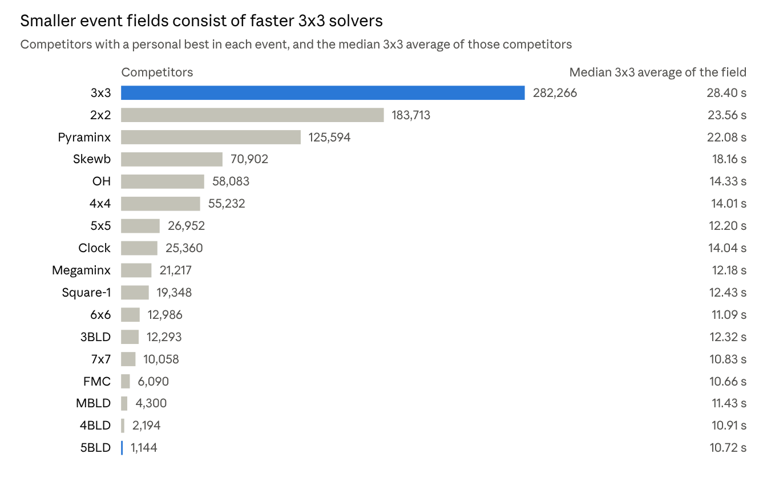
Figure 2. Competitors with a personal best in each event and the median 3x3 average among them (3BLD, 4BLD, 5BLD and MBLD by best single). WCA export of 14 October 2026.
We place every event on the 3x3 field by equipercentile linking through a common group. For event e, the common group Gₑ consists of the nₑ competitors with personal bests in both e and 3x3. These groups are self-selected and differ by event; they are not a single-group design in which one group takes both forms under controlled conditions (Kolen and Brennan 2014). A result x in event e is mapped in three steps:
- u = Fₑ(x): its position in the common group, the smoothed share of Gₑ at least as fast in event e.
- t = F₃⁻¹(u): the 3x3 result at the same position among the 3x3 results of the same group.
- q = 1 − (N·F_ref(t) + 1/2)/(N + 1): the share of the full 3x3 field that t beats, with t counted as a new member.
A competitor with no 3x3 result is rated in event e through a conversion estimated on others. The conversion applies to them if the relation between event-e and 3x3 standing among those who enter both events also holds among those who do not, that is, if 3x3 entry is missing at random given the event-e result. Competitors choose their events, so this is an assumption; its consequences are measured below through population invariance and in Sections 4.3 and 4.4.
Every distribution is continuized with a Gaussian kernel on log results (von Davier, Holland and Thayer 2004):
F(y) = \frac{1}{n}\sum_{i=1}^{n}\Phi\!\left(\frac{y - a\,y_i - (1-a)\,\bar{y}}{a\,h}\right),\qquad a = \sqrt{\frac{\sigma^2}{\sigma^2+h^2}},\qquad h = 0.9\,\min\!\left(\sigma,\frac{\mathrm{IQR}}{1.34}\right)n^{-1/5} \tag{2}
where y_i are the log results, ȳ and σ their mean and standard deviation, and h the bandwidth rule of Silverman (1986); for the 3x3 field h is 0.07 standard deviations. The factor a preserves the mean and variance of the data. Smoothing removes the steps of the empirical distribution, which at the top of small fields would make ratings jump between neighbouring ranks, and it gives the reference event and the linked events the same treatment of ties. Without a common rule, the tie convention alone would cap the leaders of linked events below the leader of the reference event. In the extreme tail the kernel, rather than the data, shapes the leading ratings: halving or doubling the bandwidth moves the 3x3 leader between 3501 and 3440 and the top-20 overall ratings by 28–45 points on average (Section 4.3).
The blindfolded events enter by single (Section 2). Rating them by average would shrink the 3BLD, 4BLD and 5BLD fields from 12,293, 2,194 and 1,144 competitors to 3,754, 549 and 220; Section 4.3 reports that variant.
What linking assumes. Equipercentile linking treats competitors at the same position in the two distributions of the common group as equally strong. The linked rating of a result in event e is the 3x3 standing of the competitor who holds the same position in the common group's 3x3 distribution. This is equating when both results measure the same ability and concordance when they measure closely related abilities; Dorans (2004) proposes a correlation of 0.866 between the two scores as the minimum for a concordance. Table 1 reports the Pearson correlation of normal scores within each common group and four further diagnostics. Only 2x2 (0.89) reaches the threshold; 4x4 (0.86), OH (0.85) and 5x5 (0.77) come close, and the blindfolded events are far below it (0.19–0.36). For most events the linking is therefore a scale alignment in the sense of Holland and Dorans (2006), not a concordance. It fixes by convention where an event's results stand relative to the 3x3 field, and for the blindfolded events that position is determined mainly by the 3x3 speed of the event's own solvers. The paper reports the cross-event placement as such a convention, with its diagnostics.
The distributions also differ in shape. Figure 3 shows the full fields up to their 99th percentile; within the common groups (Table 1), the skewness of log results ranges from −0.58 (3BLD) to 0.41 (2x2) in the linked events and from 0.27 to 0.95 in the 3x3 results of the same groups. Linear (mean–sigma) linking of log results assumes equal shapes; for the fastest 1% of each event it differs from equipercentile linking by −18 to 840 rating points.
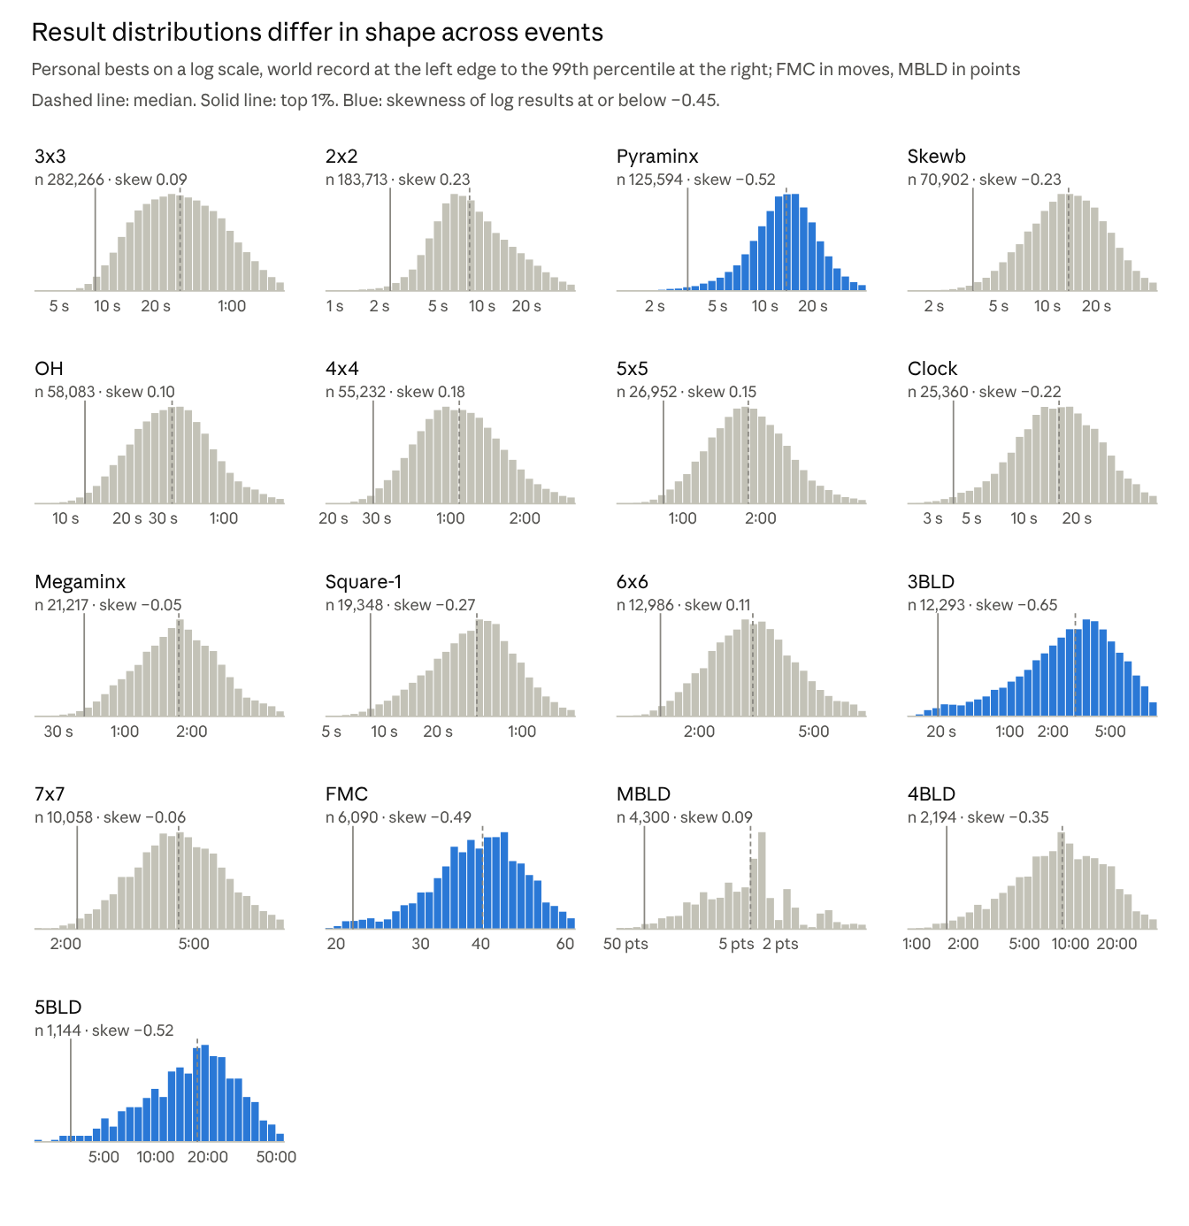
Figure 3. Personal-best distributions of the full field of each event: 30 equal-width bins in log result from the world record to the 99th percentile, bar heights scaled to each event's tallest bin; skewness of log results within that range. WCA export of 14 October 2026.
Conversions estimated separately for competitors registered up to 2017 and later, or for four world regions, differ from the whole-group conversion by a root expected mean squared difference (REMSD; Dorans and Holland 2000) of 7–74 points, against 1–27 points for random partitions of the same sizes. Relative to the standard deviation of event ratings in each event (235–314 points), this is 0.03–0.24. The conversions are therefore not population-invariant: Clock between cohorts (74 points) and 5BLD and 4BLD between regions (60 and 52) depend most on who is in the common group. Among the top 100 overall, the median gap between adjacent ranks is 1.8 points, so even the smallest of these population effects is larger than the differences that order neighbouring competitors at the top.
Table 1. Linking diagnostics by event.
Event | Common group | r | Skewness, event | Skewness, 3x3 | Linear − equipercentile, fastest 1% | Bootstrap SE, fastest 1% | REMSD, cohort | REMSD, region
2x2 | 177,448 | 0.89 | 0.41 | 0.27 | 144 | 3 | 8 (1) | 19 (2)
4x4 | 54,935 | 0.86 | 0.37 | 0.50 | −18 | 6 | 16 (1) | 9 (2)
5x5 | 26,806 | 0.77 | 0.40 | 0.56 | 13 | 9 | 14 (2) | 17 (4)
6x6 | 12,931 | 0.69 | 0.26 | 0.58 | 35 | 14 | 7 (4) | 25 (6)
7x7 | 10,008 | 0.61 | 0.11 | 0.56 | 74 | 17 | 11 (4) | 35 (7)
3BLD | 12,099 | 0.36 | −0.58 | 0.74 | 451 | 17 | 21 (4) | 37 (8)
FMC | 6,058 | 0.47 | −0.40 | 0.78 | 401 | 21 | 43 (5) | 28 (12)
OH | 57,833 | 0.85 | 0.36 | 0.50 | 28 | 6 | 22 (1) | 16 (2)
Clock | 24,903 | 0.54 | −0.07 | 0.95 | 588 | 12 | 74 (4) | 28 (7)
Megaminx | 21,079 | 0.68 | 0.11 | 0.83 | 194 | 13 | 20 (3) | 11 (6)
Pyraminx | 119,985 | 0.71 | −0.30 | 0.32 | 840 | 5 | 18 (2) | 20 (3)
Skewb | 69,682 | 0.68 | −0.07 | 0.46 | 454 | 7 | 12 (2) | 18 (3)
Square-1 | 19,226 | 0.58 | −0.10 | 0.60 | 240 | 13 | 16 (3) | 10 (5)
4BLD | 2,160 | 0.26 | −0.26 | 0.88 | 313 | 35 | 13 (11) | 52 (19)
5BLD | 1,128 | 0.22 | −0.33 | 0.78 | 334 | 54 | 33 (18) | 60 (27)
MBLD | 4,251 | 0.19 | 0.22 | 0.84 | 182 | 27 | 19 (8) | 36 (16)
r: Pearson correlation of normal scores of the event and 3x3 results within the common group; 0.866 is the minimum for a concordance in Dorans (2004). Skewness of log results within the common group. Linear − equipercentile: difference in the rating of the 1st percentile (fastest 1%) of the event between mean–sigma linking of log results and equipercentile linking. Bootstrap SE: standard deviation of that rating over 300 resamples of the common group. REMSD: root expected mean squared difference between subgroup and whole-group conversions over the 1st to 99th percentiles, for cohorts split at registration in 2017 and for regions (Asia, Europe, Americas, other); in parentheses the mean over 10 random partitions of the same sizes. All values except r and skewness in rating points.

3.3 Aggregation
An overall rating combines a competitor's event ratings R₁, …, Rₙ, where n is between 1 and 17. Criterion 3 of Section 1.1 is formalized as three requirements:
- Monotonicity. A higher event rating never lowers the overall rating.
- Sum form. The overall rating is A = f⁻¹(Σ f(Rₑ)) for a continuous, strictly increasing f with f(R) → 0 as R → −∞. Events contribute separately, an event not entered contributes nothing, entering an event never lowers the rating, and a competitor with one event has that event's rating.
- Shift equivariance. Adding a constant c to every event rating adds c to the overall rating, so that the aggregate does not depend on the origin 1200 of the scale.
The sum form is the substantive requirement. It is chosen because the rating is meant to reward career-best results without penalizing participation: under it, no competitor loses rating by entering an event. Rules that separate level and breadth, such as M_K + γ·log10 n below, can meet requirements 1 and 3 but not this property; Section 4.2 measures how often such a rule would lower a rating when an event is added. The sum form has two further consequences that the paper keeps in view: any valid result raises the rating, however little (Section 7.3), and events that share skills receive independent credit (Section 7.5).
Under requirements 1–3, f(x) = c·b^x with c > 0 and b > 1, so the overall rating is a log-sum-exp:
R = K\,\log_{10}\sum_{e} 10^{R_e/K},\qquad K = \frac{1}{\log_{10} b} \tag{3}
This is the classical characterization of translation-invariant quasi-arithmetic means and sums (Hardy, Littlewood and Pólya 1934, ch. III; Aczél 1966); Appendix A gives the short argument for the sum form used here. It fixes the form of the rule but not K. The requirements are stated for real-valued ratings. With the floor of Eq. (1), the implemented rule is shift-equivariant only for shifts that keep every event rating above 0, which excludes the 374 floored event ratings; a change of reference event moves the origin of all event ratings (Section 4.3), and the aggregate moves with it except where the floor binds.
The log-sum-exp separates into a level and a breadth term:
R = M_K + K\log_{10} n,\qquad M_K = K\,\log_{10}\left(\frac{1}{n}\sum_{e} 10^{R_e/K}\right) \tag{4}
The exponential mean M_K lies between the arithmetic mean and the maximum of the event ratings, and K·log10 n is the credit for entering n events. K governs both: as K → 0 the rating approaches the best event and breadth credit vanishes; as K grows, M_K approaches the arithmetic mean and breadth credit grows without bound.
Choice of K. We set K = 400, the unit of the event scale. With this value
10^{(R-1200)/400} = \sum_{e}\omega_e,\qquad \omega_e = \frac{q_e}{1-q_e} \tag{5}
where ωₑ are the odds that the competitor's result in event e, after linking, beats the personal best of a randomly drawn member of the reference field. The overall rating is the sum of these odds, expressed in the unit of the event ratings. For any other K the sum runs over ωₑ^(400/K), and the overall rating is no longer in that unit. The choice is normative. No contest compares one competitor's results across events, so no observed probability corresponds to the summed odds, and the overall rating is an Elo-scaled composite rather than an Elo rating. Section 4.2 shows that a predictive criterion would select a much larger K and why that conflicts with requirement 2; Section 4.3 shows how the ranking changes with K.
At K = 400, two events at equal rating add 400·log10 2 = 120 points to that rating, and seventeen equal events add 492. A second event at a distance d below the first adds 400·log10(1 + 10^(−d/400)): 17 points at d = 400 and 2 points at d = 800. For example, a 3x3 average of 12.00 s rates 1642 and a 3BLD single of 3:00 rates 1607; together they rate 1746.
The upper tail. Near the top of the reference field, a linked result of rank r has q ≈ 1 − (2r − 1)/(2N), so Rₑ ≈ 1200 + 400·log10(2N/(2r − 1)). Among leading competitors the overall rating is therefore approximately 1200 + 400·log10 Σₑ 2N/(2rₑ − 1), where rₑ is the linked rank in event e: a harmonic sum of inverse ranks, a relative of Sum of Ranks in which a first place counts three times a second place and margins between results count only through the smoothing.
Table 2 compares the rule with the alternatives used later in the paper.
Table 2. Aggregation rules and their properties.
Rule | Overall rating | Higher event rating never worsens it | Added event never worsens it | Shift-equivariant
Log-sum-exp, K = 400 (this paper) | 400·log10 Σ 10^(Rₑ/400) | yes | yes | yes
Best event | max Rₑ (limit K → 0) | yes | yes | yes
Mean of event ratings | (1/n) Σ Rₑ | yes | no | yes
Level and breadth, separate constants | M_K + γ·log10 n | yes | no | yes
Kinch | (1/17) Σ 100·WRₑ/PBₑ | yes | yes | not defined (ratio scale)
Sum of Ranks (lower is better) | Σ rankₑ, missing event = field size + 1 | yes | yes | not defined (rank scale)

3.4 Reference population and updates
Event ratings are shares of a field, so they change when the field changes even if a competitor's own results do not. Between the field at the end of 2024 and that of October 2026, personal bests that did not change lost a median of 4–30 points per event and 35–90 points in the top 1% of each event (Section 6.3). Equating practice handles this with a fixed base population (Kolen and Brennan 2014). We adopt that rule: the distributions of Section 3.2 are estimated once on a base population and then frozen, new results are rated against the frozen distributions as new members of the field, and the base is renewed at announced dates, with the shift of each event at renewal published. We take renewal to be annual.
Three properties follow. A competitor's rating changes only when their own results change, so a retired competitor's rating never falls between renewals. The ceiling of each event is fixed by the size of the base field (3501 for the 3x3 field), so a new record ahead of every base result gains only through the smoothing. And the uncertainty of the conversions (Section 5.2) is frozen with them until the next renewal. Between renewals an update needs only Eqs. (1)–(3) evaluated for new personal bests (Section 7.4). In this paper the base is the export of 14 October 2026; Section 4 uses a base frozen at the end of 2024.

3.5 Parameters
Table 3. Constants of the rating.
Constant | Value | Role | Basis | Varied in
Median rating | 1200 | Rating of the median 3x3 competitor | Convention; differences do not depend on it (requirement 3) | —
Unit | 400 | Points per tenfold odds | Elo (1978) | Event scales fitted in 4.1
Floor | 0 | Lowest event rating | Non-negative ratings; binds for 0.04% of event ratings | 4.3 (no floor)
Reference event | 3x3 | Field that defines q | Largest field; common groups with every event | 4.3 (2x2, 4x4); 4.4
Bandwidth | Silverman (1986) | Smoothing of every distribution | Standard rule | 4.3 (×0.5, ×2)
Blindfolded events | Best single | Result entering 3BLD, 4BLD, 5BLD | WCA ranking basis; field size | 4.3 (averages)
Result per event | Personal best | What is rated | Official record; career-best estimand (1.1) | 4.3, 7.2
Aggregation constant K | 400 | Balance of level and breadth | Unit of the event scale, Eq. (5) | 4.2; 4.3 (300–1300)
Base population | Export of 14 Oct 2026, renewed annually | Frozen distributions | Equating practice | 4.1–4.2 (end-2024 base); 6.3

4 Validation
This section checks the construction against data it did not use. Section 4.1 compares event-rating differences with finishing orders in later rounds. Section 4.2 compares the aggregate with ratings in events entered later and examines what that criterion implies for K. Section 4.3 measures the effect of each design choice on the ranking, and Section 4.4 compares the 3x3-anchored linking with a latent-trait model that uses all events at once.

4.1 Event ratings and finishing orders
Event ratings are defined from personal bests (Section 3.1). This section checks whether a difference between two competitors' event ratings predicts who finishes ahead in a round. Event ratings were computed from personal bests up to the end of 2024, with distributions frozen at that date. In each 2025–26 round we sampled up to 40 pairs of competitors who both held such a rating in the event and finished in different positions; tied positions, mostly shared places after failed attempts, are excluded. This gives 2,087,000 pairs from 60,324 rounds in 4,803 competitions. We fitted
P(A \text{ ahead of } B) = \frac{1}{1 + 10^{-(R_A - R_B)/s}} \tag{6}
by maximum likelihood, with 95% confidence intervals from 100 bootstrap resamples of competitions, which keep the pairs of a round, and a competitor's rounds within a competition, together.
The pooled scale is s = 374 (95% CI 371–378), against 400 in the Elo convention (Figure 4A). The logistic curve misfits systematically (Figure 4B): up to 400 points of difference the observed share exceeds it by up to 3.3 percentage points, and beyond 400 points it falls short by 0.6–1.6 points. A lapse-logistic curve, P = ε/2 + (1 − ε)/(1 + 10^(−D/s)), with s = 314 and lapse ε = 0.046 for failed attempts and off days, fits better (log-loss 0.4022 against 0.4048 for the logistic and 0.4092 for a probit; Brier score 0.1273 against 0.1277), though it overstates upsets beyond 1200 points.
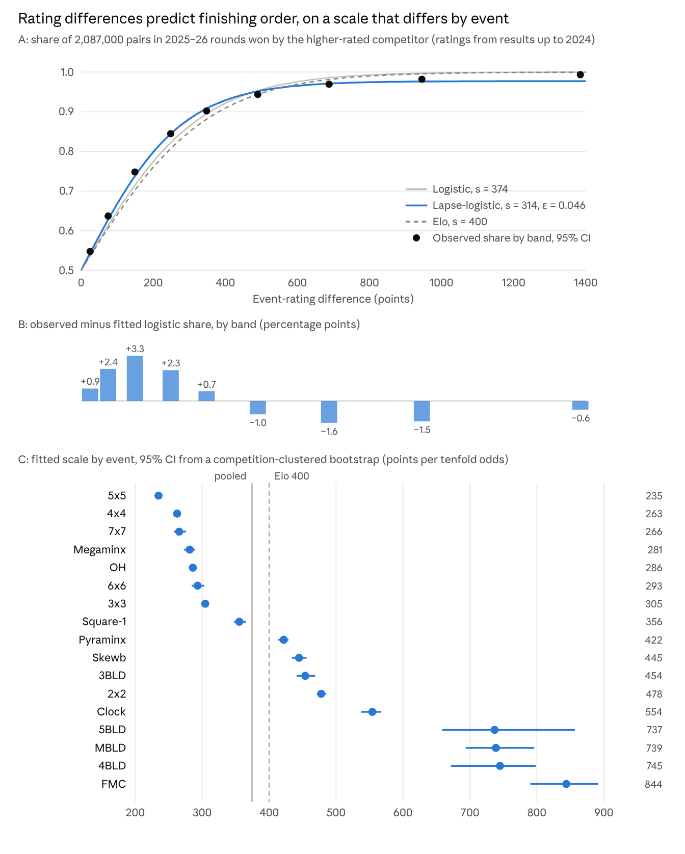
Figure 4. Event-rating differences and finishing orders: 2,087,000 pairs in 60,324 rounds of 2025–26, event ratings from personal bests up to the end of 2024. A: observed share by band of rating difference with 95% Wilson intervals, and fitted curves. B: residuals against the fitted logistic. C: scale fitted per event with 95% intervals from 100 competition-clustered bootstrap resamples; dashed line 400, grey line the pooled 374.
The scale differs between events (Figure 4C; likelihood-ratio statistic 42,543 on 16 degrees of freedom against a common scale, with the pairs treated as independent). It is 235–305 for the cube events solved sighted with long solutions (5x5, 4x4, 7x7, Megaminx, OH, 6x6, 3x3), 356–554 for Square-1, Pyraminx, Skewb, 3BLD, 2x2 and Clock, and 737–844 for 5BLD, MBLD, 4BLD and FMC. In the reference event a difference of 400 points corresponds to odds of about 20 to 1 (s = 305); in FMC, to about 3 to 1. Two causes are confounded in these values: how much the outcome of a single round depends on chance relative to skill in each event, and, for the linked events, the slope of the linking function, which stretches or compresses rating differences relative to the event's own field.
The event scale is therefore not a common head-to-head odds scale. It measures rarity within the reference field, and the head-to-head odds attached to a given rating difference depend on the event. The composite of Eq. (5) sums rarity odds, not head-to-head odds. Rescaling each event's ratings by 400/sₑ, so that a rating difference would carry the same head-to-head odds in every event, moves the leading event ratings substantially (5x5 leader 4712, FMC leader 2076) and reorders the top (Table 6). We keep the rarity scale because it is defined for every result without a model of rounds and does not depend on the format of each event, and report the rescaled variant as a sensitivity.
A Plackett–Luce model of complete finishing orders (Plackett 1975; 60,555 rounds, 1,291,281 competitor-rounds), with strength ln(10)·R/s, gives a scale of 427 points. Adding each competitor's number of earlier rounds in the event (on a log2 scale) as a covariate improves the fit strongly (likelihood-ratio statistic 55,150 on 1 degree of freedom) and lowers the scale to 361. At equal rating, each doubling of earlier rounds is worth −29 rating points in finishing order (−36 in the pairwise fit). Personal bests of frequent competitors thus overstate their typical round performance, as Section 7.2 discusses.
The test examines each event's scale within the event. No round compares competitors across events, so the cross-event placement of Section 3.2 is checked here only through its effect on the linked events' slopes.

4.2 Ratings in events entered later
No competition round mixes events, so the aggregate cannot be checked against finishing orders. One external criterion is how well a combined rating predicts a competitor's rating in an event they have not entered. We use two designs:
- Leave one event out. For each of 201,914 competitors with at least two events, and each of their events, the level term M_K of the remaining events predicts the held-out event rating. We report the Spearman correlation, averaged over events with weights proportional to the number of competitors.
- Temporal. Level terms from results up to 2024 (frozen base) predict the 2025–26 rating in 40,447 events that 18,520 competitors entered for the first time in 2025–26.
Table 4. Prediction of held-out and newly entered events by the exponential mean M_K: Spearman correlation, weighted over events.
K | Leave one out, all (201,914) | Leave one out, ≥ 4 events (85,472) | Temporal, new events (40,447)
100 | 0.774 | 0.723 | 0.420
200 | 0.781 | 0.734 | 0.433
400 | 0.789 | 0.747 | 0.448 (0.006)
800 | 0.794 | 0.755 | 0.459
1300 | 0.795 | 0.757 | 0.463 (0.006)
2200 | 0.796 | 0.758 | 0.466
5000 | 0.796 | 0.758 | 0.467
Arithmetic mean (K → ∞) | 0.795 | 0.757 | 0.469 (0.006)
Standard errors in parentheses from 100 bootstrap resamples of competitors. The differences are estimated more precisely than the levels: the mean exceeds K = 400 by 0.021 (SE 0.0014) and K = 1300 exceeds K = 400 by 0.015 (SE 0.0009) in the temporal design.
Prediction improves with K and levels off at the arithmetic mean: the best predictor of a new event is the average of a competitor's other events, not their best one (in the leave-one-out design the best event reaches 0.768 and the median 0.793). A predictive criterion would therefore choose K of 1300 or more for the level term. Under the sum form the same K also sets breadth credit, K·log10 n, which at K = 1300 is 1600 points for 17 events. A rule that separates the two, M_K + γ·log10 n, would let K be estimated (and frozen with the base) while γ fixes breadth. With K = 1300 and γ = 400, which keeps the breadth credit of K = 400 for equal event ratings, it violates requirement 2: for 26.1% of the 201,914 competitors with two or more events the rating would be higher without their weakest event (median loss 11 points), and it reorders the top (Table 6). Predicting an unseen event rewards general ability, and the composite rewards demonstrated results; the two diverge exactly in how a weaker additional event is treated. Under requirement 2, K is therefore not estimated from prediction but set by Eq. (5).
The temporal design still compares the aggregate with other overall metrics on a common criterion (Table 5).
Table 5. Overall metrics: prediction of newly entered events (temporal design, 40,447 events) and agreement with this rating (293,518 competitors).
Metric | Prediction of new events | Spearman with this rating, all | Spearman with this rating, top 1000 | Shared members of the top 100
Mean of event ratings | 0.469 | 0.95 | 0.58 | 52
Best event | 0.406 | 0.98 | 0.76 | 73
This rating (log-sum-exp, K = 400) | 0.387 | — | — | —
Sum of Ranks | 0.340 | 0.97 | 0.21 | 30
Kinch | 0.328 | 0.98 | 0.33 | 39
As a predictor of new events the composite ranks third of five, behind the mean and the best event, because its breadth term carries no information about the new event; it ranks ahead of Sum of Ranks and Kinch. Over all competitors every metric agrees closely with it (0.95–0.98), because most competitors hold one or two events; within the top 1000 agreement falls to 0.21–0.76.

4.3 Sensitivity to design choices
Each choice in Table 3 was varied in turn, with everything else fixed, together with the alternatives raised in Sections 4.1, 4.2 and 7. Table 6 compares each variant with the main rating by one top-weighted criterion, rank-biased overlap of the top 1000 (RBO, persistence 0.99; Webber, Moffat and Zobel 2010), and reports the number of the top 20 retained, the mean absolute change of the top-20 ratings and the median rating.
Table 6. Sensitivity of the rating to design choices, ordered by rank-biased overlap with the main rating.
Variant | Competitors | RBO, top 1000 | Spearman, top 1000 | Top 20 retained | Mean change, top 20 | Median rating
Main rating | 293,518 | — | — | — | — | 1346
No floor at 0 | 293,518 | 1.00 | 1.00 | 20 | 0 | 1345
Blindfolded events by average | 293,415 | 0.98 | 0.98 | 20 | 0 | 1344
Bandwidth × 0.5 | 293,518 | 0.95 | 1.00 | 19 | 28 | 1345
Bandwidth × 2 | 293,518 | 0.92 | 0.98 | 19 | 45 | 1346
Results of 2025–26 only | 87,523 | 0.91 | 0.92 | 17 | 249 | 1366
K = 500 | 293,518 | 0.90 | 0.96 | 19 | 42 | 1374
K = 300 | 293,518 | 0.90 | 0.95 | 19 | 34 | 1318
Reference event 2x2 | 293,518 | 0.88 | 0.98 | 18 | 40 | 1280
Reference event 4x4 | 293,518 | 0.85 | 0.98 | 16 | 207 | 906
Exposure-adjusted personal bests (Section 7.2) | 293,518 | 0.85 | 0.88 | 17 | 259 | 1323
Breadth by effective number of events (Section 7.5) | 293,518 | 0.83 | 0.94 | 16 | 312 | 1238
K = 600 | 293,518 | 0.81 | 0.90 | 16 | 91 | 1405
Median of round results instead of personal best | 293,518 | 0.73 | 0.75 | 12 | 88 | 1352
Separate level and breadth, K = 1300, γ = 400 (Section 4.2) | 293,518 | 0.66 | 0.74 | 12 | 299 | 1334
Event ratings rescaled by 400/sₑ (Section 4.1) | 293,518 | 0.54 | 0.47 | 9 | 604 | 1353
K = 1300 | 293,518 | 0.49 | 0.51 | 6 | 587 | 1638
Five choices leave the top of the ranking almost unchanged (RBO ≥ 0.90): the bandwidth, the blindfolded format, K between 300 and 500, the floor, and restricting results to 2025–26 (computed on the 87,523 competitors active then). The reference event moves the origin of the scale rather than the order: with 4x4 as reference the median competitor rates 906, because the 4x4 field is stronger than the 3x3 field, and the top-20 ratings shift by 207 points on average while 16 of them remain (RBO 0.85; 0.88 with 2x2). Exposure adjustment, the effective-number breadth rule and K = 600 change the top moderately (RBO 0.81–0.85). Four variants change it substantially (RBO below 0.75): typical instead of best results, separate level and breadth constants, rescaling by 400/sₑ, and K = 1300. Each of these replaces a defining choice of Section 1.1 — career-best results, the sum form, the rarity scale and the unit of Eq. (5) — rather than a tuning constant.

4.4 Comparison with a latent-trait model
The 3x3-anchored chain uses each event's common group with 3x3 only. A latent-trait model uses all common groups at once. We fitted a one-factor model to normal scores: for competitor i and event e, zᵢₑ = μₑ + λₑθᵢ + εᵢₑ with εᵢₑ ~ N(0, ψₑ) and θᵢ ~ N(0, 1), where zᵢₑ is the normal score of the result within the event's own field (Bartholomew, Knott and Moustaki 2011). It was fitted by EM with event entry treated as missing at random, which is the same assumption as in Section 3.2 and equally questionable.
Loadings are highest for 5x5, 4x4, 6x6, OH and 7x7 (1.23–1.35 on the within-field scale) and lowest for the blindfolded events (0.29–0.49), whose results are mostly unique variance (ψ = 0.85–0.94). The latent factor measures a general ability and ranks competitors like the mean of event ratings (Spearman 0.85 in the top 1000), not like the composite (0.53 in the top 1000; 8 of the top 20 and 61 of the top 100 shared). It also places event leaders differently. The leading result of each event, taken alone, implies a latent level that ranks 3x3 first and the blindfolded events last: in rating units, 3371 for the 3x3 leader against 1549–1889 for the leaders of MBLD, 5BLD, 4BLD and 3BLD, because a blindfolded result carries little information about the general factor and is shrunk towards the mean. The rank correlation between the latent and the linked leader ratings over the 17 events is 0.82.
A latent placement therefore widens the spread of event ceilings in Table 9 rather than narrowing it. It answers a different question, what a result implies about general ability, and it shows that the cross-event placement is a choice of estimand, not a measurement problem that a richer linking model would remove. The fit takes 69 seconds, so a latent-trait linking would also be feasible within criterion 5 (Section 7.4).

5 Results
This section reports what the rating produces on the export of 14 October 2026: ratings of constructed profiles (5.1), the leaderboard with its uncertainty (5.2), the distribution over all competitors (5.3), and the ceilings that the fields impose on each event (5.4).

5.1 Example profiles
Table 7 rates three constructed profiles, placed by their overall rating at the 37th, 86th and 98th percentiles of the rated population, and two competitors from the top 100, one with a single event and one with sixteen.
Table 7. Example profiles. Results are averages, except the 3BLD single.
Profile | Results | Event ratings | Best event | Overall (percentile)
Constructed A | 3x3 45 s, 2x2 15 s, Pyraminx 20 s | 1014, 1038, 1055 | 1055 | 1227 (37th)
Constructed B | 3x3 20 s, 2x2 7 s, Pyraminx 8 s, Skewb 9 s, 4x4 1:30, OH 40 s | 1345, 1344, 1617, 1584, 1387, 1439 | 1617 | 1800 (86th)
Constructed C | 3x3 10 s, 2x2 3.5 s, Pyraminx 4.5 s, Skewb 5 s, 4x4 40 s, 5x5 1:20, OH 16 s, 3BLD single 1:00 | 1799, 1790, 1935, 1931, 1865, 1835, 1976, 1946 | 1976 | 2258 (98th)
Rank 44, one event | 3x3 only | 3056 | 3056 | 3056
Rank 99, sixteen events | Four highest: Clock, 5x5, 6x6, 7x7 | 2736, 2675, 2583, 2561 | 2736 | 2970
Aggregation adds 172, 183 and 282 points above the best event for the three constructed profiles and 234 points for the sixteen-event competitor. The two top-100 competitors reach similar ratings by different routes: one event at 3056, or sixteen events with a best of 2736.

5.2 Leaderboard and its uncertainty
A rating carries two kinds of uncertainty. The first comes from the conversions: every distribution of Section 3.2 is estimated from the competitors who happened to compete, and a different field of the same kind would give slightly different conversions. We estimate it with a person-level bootstrap that treats the field as a sample from the population of competitors who could have entered. Each replicate resamples the 293,518 competitors with replacement, each with all of their personal bests, re-estimates all 17 kernel distributions and 16 linkings, and rates the original top 5,000; a rated competitor drawn k times is evaluated against the resample without their own copies, as a new member (Section 3.1). The second comes from performance: a personal best is the best of a competitor's own rounds, and other rounds could have produced another best. We estimate it by resampling each top-5,000 competitor's own round results with replacement in each event, taking the best, and rating it with the conversions fixed. Each bootstrap has 400 replicates. Because the conversion bootstrap distribution lies above the point estimates (by a median of 11 points in the top 20), we report basic intervals (Davison and Hinkley 1997) for it. The performance bootstrap cannot produce a result better than the observed best, so its intervals extend downwards only; we report them as percentile intervals. Rank intervals are ranks within the top 5,000. The leading ratings depend on the extreme tail of each distribution, where the nonparametric bootstrap is not consistent (Bickel and Freedman 1981); smoothing every resample reduces the discreteness that causes this failure (Hall, DiCiccio and Romano 1989), but intervals for the leaders remain approximate.
Table 8 lists the top 20 without identifiers, because several ranked competitors are minors.
Table 8. The 20 highest overall ratings with 95% intervals for conversion uncertainty (basic bootstrap) and performance uncertainty (round resampling), 400 replicates each.
Rank | Country | Events | Two highest event ratings | Rating | Conversion 95% interval | Performance 95% interval | Rank interval, conversion | Rank interval, performance
1 | CN | 8 | 3x3 3472, 2x2 3274 | 3524 | 3445–3576 | 3369–3524 | 1–3 | 1–4
2 | RU | 13 | 5x5 3262, 4x4 3161 | 3417 | 3267–3564 | 3304–3417 | 1–10 | 1–6
3 | PL | 15 | 4x4 3298, 5x5 3074 | 3396 | 3249–3525 | 3361–3396 | 2–11 | 1–4
4 | CN | 4 | OH 3369, 3x3 2832 | 3378 | 3264–3614 | 3094–3378 | 2–23 | 2–24
5 | US | 8 | 4x4 3270, 5x5 3014 | 3377 | 3239–3508 | 3275–3377 | 3–12 | 3–9
6 | CN | 4 | 3x3 3340, 4x4 2446 | 3341 | 3143–3523 | 3306–3341 | 1–20 | 3–7
7 | US | 6 | 2x2 3306, 3x3 2045 | 3307 | 3146–3412 | 3120–3307 | 3–18 | 5–18
8 | CN | 4 | Pyraminx 3286, 3x3 2848 | 3299 | 3094–3486 | 3173–3299 | 2–26 | 6–16
9 | PL | 15 | Skewb 3277, 2x2 2494 | 3283 | 3078–3492 | 2956–3283 | 2–37 | 7–95
10 | AU | 10 | Pyraminx 3249, 2x2 2715 | 3258 | 3014–3438 | 2923–3258 | 3–38 | 8–127
11 | CZ | 15 | Skewb 3201, Megaminx 2449 | 3209 | 2959–3383 | 3003–3209 | 4–56 | 9–58
12 | PL | 14 | 2x2 3094, 3x3 3035 | 3206 | 3084–3266 | 3127–3206 | 8–23 | 9–20
13 | VN | 16 | 5x5 3008, 4x4 2997 | 3206 | 3004–3279 | 3168–3205 | 5–22 | 9–17
14 | CN | 10 | Megaminx 3005, 7x7 2915 | 3202 | 3093–3283 | 3181–3202 | 8–24 | 9–16
15 | SG | 12 | 2x2 3180, Clock 2731 | 3198 | 3028–3301 | 3024–3198 | 5–35 | 10–45
16 | CN | 4 | 3x3 3194, 2x2 2040 | 3194 | 2955–3317 | 2965–3194 | 3–40 | 10–89
17 | US | 17 | OH 3050, 3x3 2895 | 3192 | 3053–3244 | 3110–3192 | 7–23 | 11–22
18 | KR | 13 | 5x5 2948, 4x4 2930 | 3186 | 3060–3252 | 3163–3186 | 10–25 | 12–18
19 | US | 14 | 2x2 3120, Skewb 2916 | 3176 | 3027–3251 | 3100–3176 | 8–32 | 13–25
20 | US | 14 | FMC 3050, Square-1 2836 | 3172 | 2974–3244 | 3054–3172 | 5–34 | 14–37
The leader is first in 82% of conversion replicates and 77% of performance replicates (rank intervals 1–3 and 1–4). Below the leader the two sources differ. Conversion uncertainty is largest for ratings that rest on a leading result in a field with a sparse tail: the median width of the conversion interval is 274 points in the top 20, 148 in the top 100 and 47 in the top 1000. Performance uncertainty is largest where a rating rests on one exceptional round: the performance rank intervals of the competitors at ranks 9, 10 and 16 reach down to ranks 95, 127 and 89, while those at ranks 12–14, 17 and 18, with many strong rounds in cube events, move by fewer than 15 places. The median width of the performance interval is 115 points in the top 20, 59 in the top 100 and 49 in the top 1000. Both kinds of interval describe the sensitivity of the ranking to the field and to past rounds; neither covers how competitors will perform in future rounds.
Nine of the top 20 hold between 4 and 10 events and eleven hold between 12 and 17. Their highest event ratings range from 2948 to 3472, and their overall ratings exceed their best event by 0–238 points.

5.3 Distribution
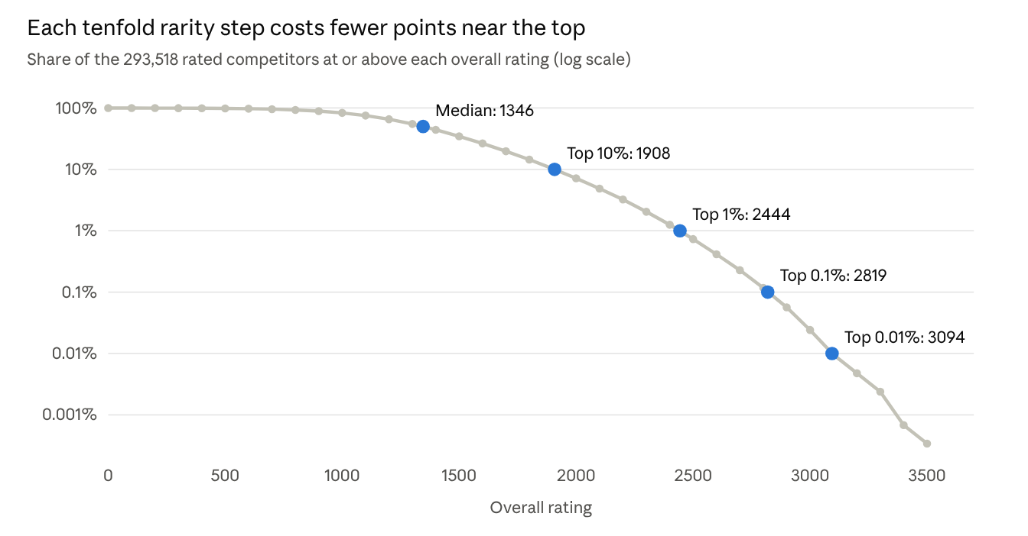
Figure 5. Share of the 293,518 rated competitors at or above each overall rating, at 100-point steps, log scale; blue points mark the median and the top 10%, 1%, 0.1% and 0.01%. WCA export of 14 October 2026.
Overall ratings range from 0 to 3524, with a median of 1346 (Figure 5). 254 competitors rate 0, 2,148 rate 2500 or more and 71 rate 3000 or more. The thresholds of the top 10%, 1%, 0.1% and 0.01% are 1908, 2444, 2819 and 3094. Moving from the median to the top 10% costs 562 points, against 382 points within one event, where the odds of beating a random field member rise from 1 to 9. Each further tenfold step in rarity costs 536, 375 and 275 points, against 417, 402 and 400 within one event. Up to the top 1% the overall steps are larger, because stronger competitors enter more events and collect breadth credit; above it they are smaller, because the leading ratings are bounded by the event ceilings described next.

5.4 Ceilings and the 3x3 field
The leading rating of each event depends on the size of the reference field and on how far the event's leader is ahead of their common group. Table 9 lists the leading rating of each event after linking, the rating the same result would receive against its own field alone, and the overall rank that a competitor holding only that leading result would have.
Table 9. Event ceilings.
Event | Competitors | Median rating | Leader, linked | Leader, own field | Overall rank with this result alone
3x3 | 282,266 | 1200 | 3472 | 3472 | 2
OH | 58,083 | 1519 | 3369 | 3236 | 6
2x2 | 183,713 | 1267 | 3306 | 3299 | 8
4x4 | 55,232 | 1533 | 3298 | 3077 | 9
Pyraminx | 125,594 | 1293 | 3286 | 3285 | 9
Skewb | 70,902 | 1386 | 3277 | 3179 | 10
5x5 | 26,952 | 1629 | 3262 | 2983 | 10
Megaminx | 21,217 | 1630 | 3066 | 3012 | 40
FMC | 6,090 | 1734 | 3050 | 2646 | 46
6x6 | 12,986 | 1705 | 3020 | 2887 | 65
Clock | 25,360 | 1529 | 3020 | 2992 | 65
Square-1 | 19,348 | 1613 | 2980 | 2870 | 87
7x7 | 10,058 | 1726 | 2975 | 2732 | 90
3BLD | 12,293 | 1623 | 2955 | 2754 | 115
4BLD | 2,194 | 1717 | 2892 | 2646 | 179
5BLD | 1,144 | 1727 | 2888 | 2516 | 183
MBLD | 4,300 | 1669 | 2840 | 2523 | 258
A linked leader's rating is, up to smoothing, the 3x3 standing of the fastest 3x3 solvers in its common group at the position 1/(2nₑ) of that group. Linking therefore raises the leaders of small fields of fast 3x3 solvers well above what their own fields would give (FMC 2646 to 3050, 5BLD 2516 to 2888, MBLD 2523 to 2840); in the large fields of 3x3, 2x2 and Pyraminx the two values coincide. The leading ratings still differ by 632 points between 3x3 and MBLD, so a single leading result places its holder between 2nd (3x3) and 258th (MBLD). These ceilings follow from field size and composition, not from the difficulty of the achievements; Section 7.3 discusses this as a normative property of the rating.
The 3x3 field is the largest, and its leading result has the highest ceiling. The current overall leader holds that result and seven further events: with the 3x3 result alone they would rate 3472 and rank 2nd, and the other events add 52 points. A competitor holding only the leading 3x3 result would need one further event at 3289, two at 3169 or four at 3048 to reach the current top rating of 3524. A record margin counts only through smoothing: a result 0.1% faster than the current 3x3 leader would rate 3476, 4 points higher. A competitor holding the leading result in every event would rate 400·log10 Σ 10^(Rₑ/400) over the 17 leading ratings, which is 3707 (3704 without Clock), 183 points above the current leader.

6 Behaviour of the rating
This section describes how the rating responds to changes that competitors or the WCA can make: an improved result (6.1), more events entered (6.2), growth of the field (6.3) and the removal of an event (6.4). The introduction of a new event is simulated in Appendix B.

6.1 Improvement
A 3x3 average of 60, 30, 20, 15, 10, 7 and 5 s rates 877, 1179, 1345, 1492, 1799, 2255 and 2860. Figure 6 shows the gain from a 10% faster average at each level. It is smallest near the median (41 points at 30 s) and grows towards the top (193 points at 6 s), where an improvement passes a large share of the few remaining faster competitors. The stretched lower tail gives slow competitors slightly more than median ones (68 points at 90 s). Close to the leading results the gain falls again (141 points at 5 s), because ratings there approach the ceiling of Section 3.1.
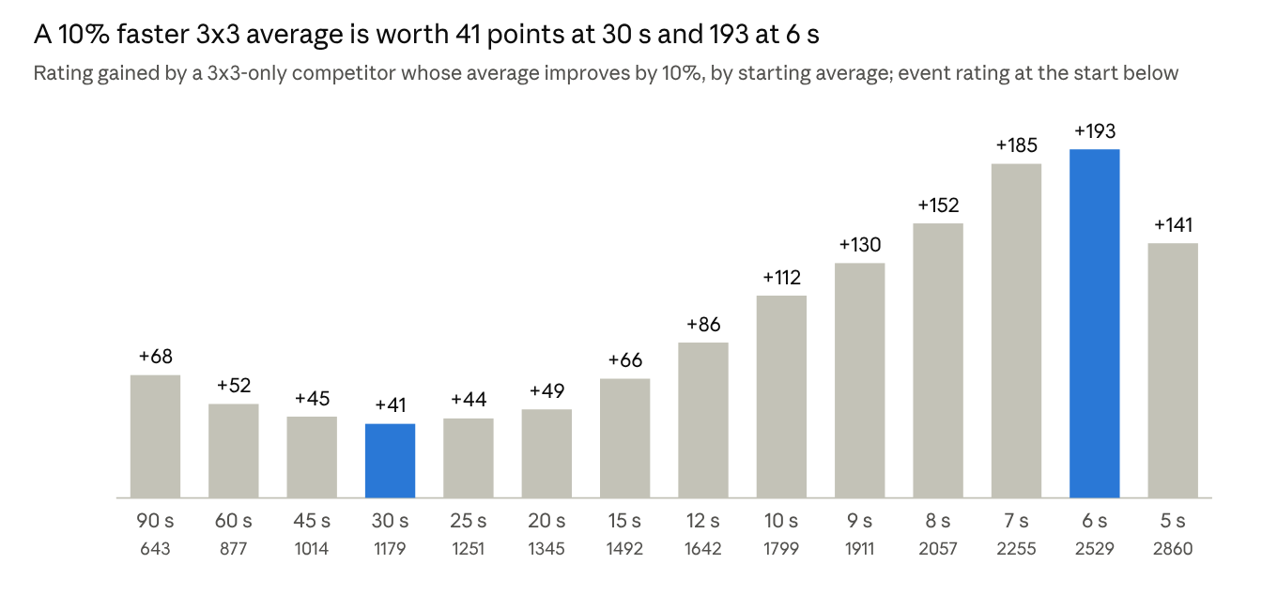
Figure 6. Rating gained by a 3x3-only competitor whose average improves by 10%, at 14 starting averages, with the event rating at the start; ratings against the full 3x3 field of 282,266 competitors.

6.2 Breadth
Breadth credit is bounded by construction (Section 3.3): 120 points per doubling of the number of events at equal rating, and 492 points for all 17. In the data, the overall rating exceeds a competitor's best event rating by a median of 85 points over all competitors, 112 in the top 100 and 145 in the top 1000, with a maximum of 418. Competitors in the top 100 hold a median of 14 events, against 2 over all competitors, and 2 of the top 100 hold a single event. Breadth credit is of the same size as the rating differences that order the top of the list: within the top 20 it ranges from 0 to 238 points, while the top 20 span 352 points, and rank 13 (best event 3008, 16 events) stands above rank 16 (best event 3194, 4 events).

6.3 Field growth and drift
To measure drift we rated every personal best that did not change between December 2024 and October 2026 against distributions estimated at both dates. Figure 7 shows the change. The median result lost 4–30 points depending on the event, and results in the top 1% of each event lost 35–90 points. Losses are largest at the top in Clock, 6x6, FMC and 7x7, and smallest in the large fields of 2x2, Pyraminx and 3x3. The direction is the same in every event: newcomers and improving competitors push unchanged results down, and the leading results improved more than the rest.
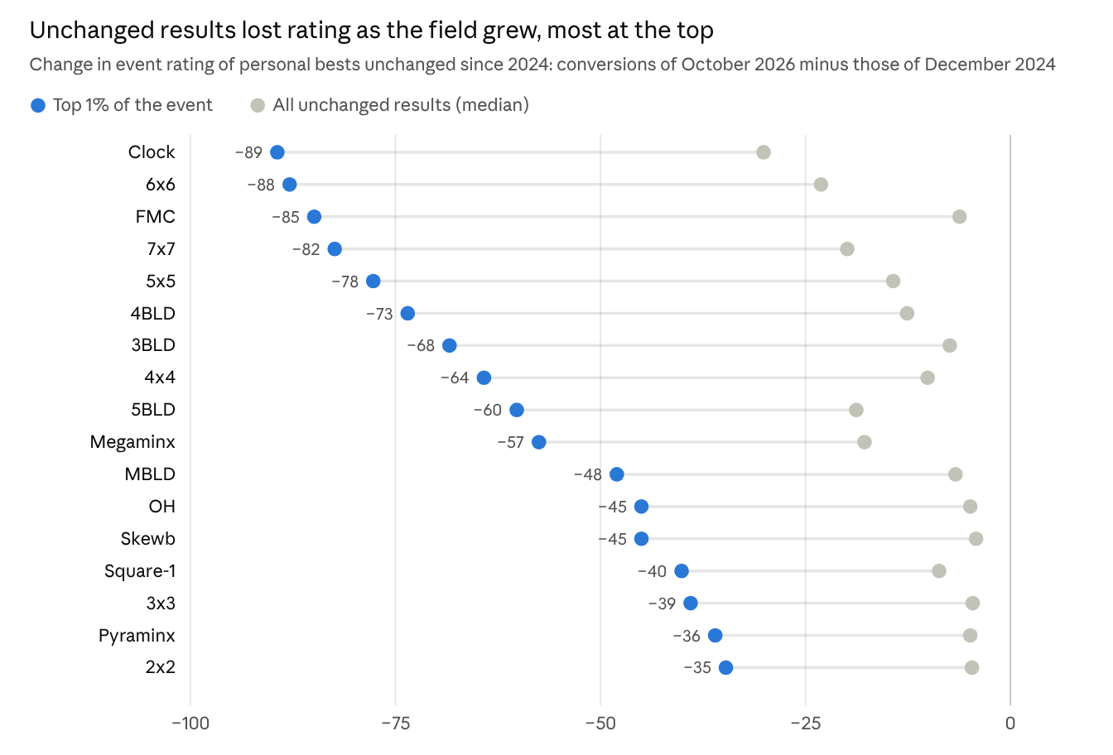
Figure 7. Change in the event rating of personal bests that did not change between December 2024 and October 2026, when the distributions are re-estimated on the October 2026 field instead of the December 2024 field. Median over all such results and over those in the top 1% of the 2024 ratings of each event.
Under the frozen base of Section 3.4 these changes are zero between renewals. At an annual renewal they occur at once, by amounts of roughly half those shown in Figure 7, which covers 22 months, and are published as a shift per event. The tests of Sections 4.1 and 4.2 were run under a base frozen at the end of 2024, so they describe the rating as it would operate under this rule.

6.4 Removal of an event
In June 2026 the WCA announced that FTO becomes an official event on 2 January 2027 and that Clock remains available until 18 July 2027, with the 2027 World Championship as the last competition to hold it (WCA 2026b). Whether ratings in a discontinued event are kept is a policy choice; the WCA keeps the records of discontinued events in its historical results. If Clock ratings are kept, frozen at the last base, nothing changes. If they are removed, every other event rating is unchanged, because each event is linked to 3x3 separately, and only overall ratings that include Clock move. Removal lowers the mean rating of the current top 100 by 7.4 points, with a largest loss of 379 points in the top 100. Clock is the best event of 75 of the top 1000. The largest loss in the top 1000 is 1001 points, for a competitor whose Clock rating of 2664 is far above their other events; it moves them from rank 859 to rank 63,440. The 243 competitors whose only result is in Clock would leave the rating. A new event enters the rating once its common group with 3x3 can be estimated; Appendix B simulates how quickly that conversion settles.

7 Discussion
This section states what the rating measures and what it can be used for (7.1), how it depends on the use of personal bests (7.2), how a competitor's choice of events affects it (7.3), what it costs to compute (7.4), and where its assumptions are weakest (7.5).

7.1 What the rating measures
The rating is a composite indicator of career-best standing. It combines standing in each event, as odds against the reference field, with breadth, and it meets the criteria of Section 1.1 by construction. Three findings bound its interpretation. Event-rating differences predict finishing order within rounds, but on an odds scale that differs between events (Section 4.1). The placement of events relative to one another is a convention with a measured but weak empirical basis for most events (Section 3.2, Table 1). And as a forecast of a competitor's rating in an event they have not yet entered, the rating is less accurate than the mean or the best of their event ratings (Section 4.2).
It can therefore serve as a ranking of demonstrated achievement across events, with breadth credited and no event penalized, and its differences can be read as differences in summed odds against the reference field. It is not an estimate of general cubing ability, a probability that one competitor would beat another in some event, or a forecast of results in new events. Kinch and Sum of Ranks answer yet another question: they charge every missing event, so they place all-round competitors higher, and within the top 1000 they correlate with the rating at 0.33 and 0.21 (Table 5).

7.2 Personal bests and exposure
A personal best is the best of a varying number of attempts. Table 10 shows, by the number of rounds a competitor has entered, how far the rating of their personal best lies above the rating of the median of their round results.
Table 10. Rating of the personal best minus rating of the median round result, by number of rounds with a valid result. Median over competitors, in rating points.
Rounds entered | 1 | 2–3 | 4–7 | 8–15 | 16–31 | 32–63 | 64+
3x3 competitors | 120,837 | 76,348 | 40,146 | 22,343 | 11,884 | 6,235 | 4,473
3x3 | 0 | 28 | 60 | 88 | 116 | 149 | 201
4x4 | 0 | 27 | 56 | 86 | 117 | 154 | 196
Pyraminx | 0 | 56 | 103 | 139 | 167 | 193 | 223
Part of this gap is improvement over time and part is the selection of the best of many attempts. Two analyses separate how much of it matters for prediction and for the ranking. In the Plackett–Luce fit of Section 4.1, a competitor's number of earlier rounds enters as a covariate: at equal rating, each doubling of earlier rounds lowers a competitor's expected finishing position by the equivalent of 29 rating points, close to the average gap per doubling in Table 10. And subtracting the average gap per doubling of rounds from every personal-best rating (cₑ·log2 k, where cₑ ranges from 27 to 66 points per doubling and is 30 for 3x3) gives the exposure-adjusted variant of Table 6. It retains 17 of the top 20 but lowers their ratings by 259 points on average (RBO 0.85), because leading competitors have entered many rounds.
The main rating keeps personal bests. Its estimand is career-best demonstrated performance (Section 1.1), the quantity the WCA rankings also report, and under it a rating never decreases while results do not change. A competitor who competes more has more chances to set a personal best, and the rating credits the best result obtained. A model of individual attempts with competitor effects, attempt counts and time trends would estimate current ability instead; Section 7.4 discusses what such a model would cost.

7.3 Choice of events
Every valid result raises the rating, so a competitor can raise it by entering more events. The gain depends on how close the new event rating is to the competitor's current overall rating. For the top 1000, who have a median of 3 events not yet entered, a result at the median of the new event's field would add a median of 0.36 points (at most 0.9), a result at that field's 90th percentile 3.4 points (at most 10.4), and a floored result nothing measurable. The incentive to enter events for the rating alone is therefore small at the top; it becomes material only for events in which a competitor would rate within a few hundred points of their overall rating.
Linking also makes the same position within an event worth more in events whose fields are fast 3x3 solvers: the median competitor of the 5BLD field rates 1727, against 1200 in the 3x3 field. The leading ratings of the events (Table 9) follow mechanically from each common group's size and its 3x3 composition; they do not measure how difficult the leading achievements are. A 632-point spread between the 3x3 and MBLD ceilings, and a leading MBLD result being worth rank 258, are consequences of this convention. Whether a world-leading result in a small, strong field should be worth less than one in the largest field is a normative choice that the rating makes implicitly through the reference event; Section 4.4 shows that a latent-trait placement would widen, not narrow, this spread.

7.4 Computational feasibility
Criterion 5 requires the rating to run where the WCA results run: updated within minutes of results being posted, and recomputed in full within an hour on one server. Table 11 reports the cost of each step on one core of a 2.8 GHz server in Python with NumPy.
Table 11. Computational cost of the rating (one core, 2.8 GHz).
Step | Work | Time
Personal bests from 6.93 million round results | one pass, group minimum | 8.2 s
Fit 17 field and 16 common-group distributions | binning and one convolution on an 8,192-point grid each | 0.4 s
Rate 917,732 event results | grid interpolation per result; exact kernel sum for extreme results | 5.7 s
Aggregate 293,518 competitors | one log-sum-exp of at most 17 terms each | 0.2 s
Full recomputation (renewal) | sum of the above | about 15 s
Update after one competition (Euro 2026: 9,981 results, 1,157 competitors) | rate changed personal bests against the frozen base | 1.5 s
Conversion bootstrap, 400 replicates (Section 5.2) | 400 full refits | about 35 min
Latent-trait model (Section 4.4) | 200 EM iterations on 293,518 × 17 | 69 s
A full recomputation takes about 15 seconds, roughly 240 times less than the one-hour limit, and an update after a large competition takes 1.5 seconds once its results are in the database. The rating can therefore be published together with the official rankings, and a competitor can see how a new personal best changes their rating as soon as the result is posted. The budget leaves room for several extensions requested in review, and it also marks which ones belong in the rating and which only in its validation:
- Per-result corrections that are a fixed function of a result and a count, such as event-specific rescaling (Section 4.1) or the exposure adjustment of Section 7.2, add one table lookup per result and fit within the update limit.
- Models refitted at renewal, such as the latent-trait linking of Section 4.4, cost seconds to minutes and fit the annual renewal, provided their estimates are frozen between renewals like the conversions.
- Uncertainty intervals by bootstrap cost about half an hour per renewal; they fit the renewal limit but not an update after each competition, so intervals would be refreshed with the base.
- Attempt-level models with competitor random effects and time trends, fitted to some 30 million attempts, would need iterative estimation at every renewal and approximate updates of each competitor's effect between renewals. They are not excluded by the limit, but they move the rating from a deterministic function of the record to a model estimate that changes when other competitors' results change, which conflicts with criterion 4.

7.5 Limitations
- Linking conditions. Only 2x2 meets the threshold for a concordance; the blindfolded events have r = 0.19–0.36, and conversions vary with cohort and region by 7–74 points (Table 1). Every event is linked through 3x3 alone; the latent-trait comparison of Section 4.4 uses all common groups and assumes entry at random, which is not credible for events competitors choose.
- Event scales. Rating differences translate into different odds of finishing ahead in different events (Section 4.1), so equal rating differences do not mean equal head-to-head odds across events.
- Uncertainty. The conversion bootstrap of Section 5.2 treats the field as a sample from the competitors who could have entered; it is approximate at the extreme top. The performance bootstrap resamples a competitor's own rounds and cannot produce a result better than their best, so its intervals extend mainly downwards.
- Correlated events. Events that share skills receive independent breadth credit. The correlations between event ratings among competitors who hold both range from 0.10 to 0.94, and by the participation ratio the 17 events carry about 2.1 effective dimensions; a top-100 competitor's 14 events carry about 1.8. Crediting breadth by effective rather than nominal number of events (Table 6) would remove most breadth credit and, being built on the exponential mean, would no longer guarantee requirement 2.
- Field dependence. A rating depends on who else competes: a newcomer faster than a given result lowers it at the next renewal (Section 6.3).
- Simulation assumptions. The new-event results of Appendix B depend on the stand-in events and on the adoption rule, and measure error relative to a self-selected full group.

8 Conclusion
A personal best is placed on an event scale as the log-odds, in Elo units, of beating the personal best of a random member of the 3x3 field; the other 16 events are placed on that field by kernel-smoothed equipercentile linking through their common groups; and event ratings are summed as odds by a log-sum-exp with K = 400, the form of quasi-arithmetic sum that does not depend on the origin of the scale. The result is a composite indicator of career-best standing that never penalizes entering an event, stays fixed between annual renewals of its reference field, and can be recomputed for all 293,518 competitors in about 15 seconds.
The evidence qualifies how the rating can be read. Event-rating differences predict finishing order within later rounds with a pooled scale of 374 points per tenfold odds, but the scale differs between events from 235 to 844. Linking reaches the conventional strength of a concordance only for 2x2, so the relative placement of events is a documented convention. As a forecast of ratings in newly entered events the rating ranks behind the mean and the best event rating, and personal bests rise with the number of rounds entered. The top of the ranking is stable under the bandwidth, the blindfolded format and K between 300 and 500, shifts moderately with the reference event and with an adjustment for exposure, and changes substantially when personal bests are replaced by typical results or event ratings by head-to-head scales. The rating is suited to ranking demonstrated achievement across events; it is not an estimate of general ability or a head-to-head probability across events.

Data and code availability
The data are the WCA results export, format version 2.0.2, of 14 October 2026 (WCA 2026a), read from the mirror of Ingelbrecht (2026) at commit 7e0374bc; the attribution required by the WCA is given in Section 2. The Python code that builds the data sets, computes the ratings and produces every number, table and figure, with a README that maps each script to its section, is provided as supplementary material and will be deposited in a persistent archive with a DOI on acceptance. A table of event and overall ratings for all rated competitors is provided subject to the journal's policy on identifiable data, since some competitors are minors.

References
Aczél, J. (1966). Lectures on Functional Equations and Their Applications. Academic Press.
Bartholomew, D. J., Knott, M., & Moustaki, I. (2011). Latent Variable Models and Factor Analysis: A Unified Approach (3rd ed.). Wiley.
Bickel, P. J., & Freedman, D. A. (1981). Some asymptotic theory for the bootstrap. Annals of Statistics, 9(6), 1196–1217. https://doi.org/10.1214/aos/1176345637
Bradley, R. A., & Terry, M. E. (1952). Rank analysis of incomplete block designs: I. The method of paired comparisons. Biometrika, 39(3/4), 324–345. https://doi.org/10.2307/2334029
cuberoot.me (n.d.). Sum of Ranks. WCA statistics.
Davison, A. C., & Hinkley, D. V. (1997). Bootstrap Methods and Their Application. Cambridge University Press.
de Finetti, B. (1931). Sul concetto di media. Giornale dell'Istituto Italiano degli Attuari, 2, 369–396.
Dorans, N. J. (2004). Equating, concordance, and expectation. Applied Psychological Measurement, 28(4), 227–246. https://doi.org/10.1177/0146621604265031
Dorans, N. J., & Holland, P. W. (2000). Population invariance and the equatability of tests: Basic theory and the linear case. Journal of Educational Measurement, 37(4), 281–306. https://doi.org/10.1111/j.1745-3984.2000.tb01088.x
Elo, A. E. (1978). The Rating of Chessplayers, Past and Present. Arco.
Glickman, M. E. (1999). Parameter estimation in large dynamic paired comparison experiments. Journal of the Royal Statistical Society: Series C, 48(3), 377–394. https://doi.org/10.1111/1467-9876.00159
Grand Chess Tour (2017). Grand Chess Tour announces Universal Rating System. ChessBase.
Hall, P., DiCiccio, T. J., & Romano, J. P. (1989). On smoothing and the bootstrap. Annals of Statistics, 17(2), 692–704. https://doi.org/10.1214/aos/1176347135
Hardy, G. H., Littlewood, J. E., & Pólya, G. (1934). Inequalities. Cambridge University Press.
Herbrich, R., Minka, T., & Graepel, T. (2007). TrueSkill: A Bayesian skill rating system. Advances in Neural Information Processing Systems, 19, 569–576.
Holland, P. W., & Dorans, N. J. (2006). Linking and equating. In R. L. Brennan (Ed.), Educational Measurement (4th ed., pp. 187–220). American Council on Education and Praeger.
Hunter, D. R. (2004). MM algorithms for generalized Bradley–Terry models. Annals of Statistics, 32(1), 384–406. https://doi.org/10.1214/aos/1079120141
Ingelbrecht, R. (2026). wca-rest-api: static mirror of the WCA results export, commit 7e0374bc. GitHub repository.
International Association of Athletics Federations (2001). IAAF Scoring Tables for Combined Events. IAAF.
Kolen, M. J., & Brennan, R. L. (2014). Test Equating, Scaling, and Linking (3rd ed.). Springer.
Kolmogorov, A. N. (1930). Sur la notion de la moyenne. Atti della Reale Accademia Nazionale dei Lincei, Rendiconti, 12, 388–391.
Krakauer, D., Kardeş, G., & Grochow, J. (2025). Universality in collective intelligence on the Rubik's Cube. arXiv:2511.18609.
Luce, R. D. (1959). Individual Choice Behavior: A Theoretical Analysis. Wiley.
Nagumo, M. (1930). Über eine Klasse der Mittelwerte. Japanese Journal of Mathematics, 7, 71–79.
OECD & European Commission Joint Research Centre (2008). Handbook on Constructing Composite Indicators: Methodology and User Guide. OECD Publishing.
Plackett, R. L. (1975). The analysis of permutations. Journal of the Royal Statistical Society: Series C, 24(2), 193–202. https://doi.org/10.2307/2346567
Saito, R. (2025). Modeling realistic placement probabilities in speedcubing using kernel density estimation. Wharton Sports Analytics Journal, Fall 2025.
Schütz, M., & Tofallis, C. (2024). A multiplicative approach to decathlon scoring based on efficient frontiers. Journal of Quantitative Analysis in Sports, 20(2), 179–192. https://doi.org/10.1515/jqas-2022-0012
Silverman, B. W. (1986). Density Estimation for Statistics and Data Analysis. Chapman and Hall.
speedsolving.com (n.d.). KinchRanks: all-round rankings.
Stefani, R. T. (1997). Survey of the major world sports rating systems. Journal of Applied Statistics, 24(6), 635–646. https://doi.org/10.1080/02664769723387
von Davier, A. A., Holland, P. W., & Thayer, D. T. (2004). The Kernel Method of Test Equating. Springer.
Webber, W., Moffat, A., & Zobel, J. (2010). A similarity measure for indefinite rankings. ACM Transactions on Information Systems, 28(4), 20. https://doi.org/10.1145/1852102.1852106
Woolf, A., Ansley, L., & Bidgood, P. (2007). Grouping of decathlon disciplines. Journal of Quantitative Analysis in Sports, 3(4), 5. https://doi.org/10.2202/1559-0410.1057
World Cube Association (2026a). Results export, format version 2.0.2, 14 October 2026.
World Cube Association (2026b). Changes to the WCA's list of official events (June 2026). WCA news post by O. Hexter.

Appendix A. The log-sum-exp as the shift-equivariant sum
The characterization is classical (Hardy, Littlewood and Pólya 1934, ch. III; Aczél 1966); we give the argument for the sum form of Section 3.3. Let f: ℝ → (0, ∞) be continuous and strictly increasing with f(x) → 0 as x → −∞, and A(R₁, …, Rₙ) = f⁻¹(Σ f(Rₑ)). For A to be defined for all ratings, the range of f must be closed under addition; being an interval with infimum 0, it is (0, ∞). Shift equivariance for two events states that, for all x, y and c,
f^{-1}\big(f(x+c) + f(y+c)\big) = f^{-1}\big(f(x) + f(y)\big) + c \tag{A1}
With g_c(s) = f(f⁻¹(s) + c) for s > 0, s = f(x) and t = f(y), applying f to both sides gives Cauchy's equation g_c(s + t) = g_c(s) + g_c(t) on the positive half-line. Its continuous solutions are linear, g_c(s) = λ(c)·s with λ(c) > 0, so f(x + c) = λ(c)·f(x) for all x and c. Setting x = 0 gives λ(c) = f(c)/f(0), and φ(x) = f(x)/f(0) satisfies φ(x + c) = φ(x)·φ(c) with φ(0) = 1, whose continuous positive solutions are φ(x) = b^x (Aczél 1966); b > 1 because f is increasing. Hence f(x) = f(0)·b^x and
A(R_1,\dots,R_n) = \log_b \sum_{e} b^{R_e} = K \log_{10} \sum_{e} 10^{R_e/K},\qquad K = \frac{1}{\log_{10} b} \tag{A2}
The two-event case determines f and with it the rule for any number of events. Conversely, the log-sum-exp is strictly increasing in each argument, an added event adds a positive term inside the logarithm, and K·log10 Σ 10^((Rₑ + c)/K) = c + K·log10 Σ 10^(Rₑ/K). ∎
Remarks. (i) The argument is stated for ratings on the real line, the scale of Eq. (1) before the floor. The floor is applied to event ratings before aggregation; on the floored domain [0, ∞) an event not entered is assigned f = 0, the limit of f below every attainable rating, and entering any event raises the rating because f > 0 there. (ii) The best event, max Rₑ, satisfies requirements 1 and 3 but not the sum form; it is the limit of the log-sum-exp as K → 0. (iii) The result does not identify K: every b > 1 gives a shift-equivariant sum, and K = 400 rests on Eq. (5).

Appendix B. Introduction of a new event
FTO becomes an official event on 2 January 2027 (WCA 2026b). Its rating needs a common group with 3x3, which forms as competitors adopt the event. This appendix measures how the linking error depends on the number of adopters and on who adopts first.
We used the common groups of Megaminx (21,079 competitors) and Square-1 (19,226) as stand-ins for a new event. For n adopters drawn without replacement from a stand-in's common group, we estimated the conversion of Section 3.2 from those n competitors alone, rated them, and compared these ratings with the ratings from the conversion of the full common group. Adopters were drawn either uniformly or with probability proportional to 10^((R − median R)/τ), where R is a competitor's overall rating from their other events, for τ = 800 and τ = 400; under the selective rules stronger competitors adopt first. Each point averages 100 runs.
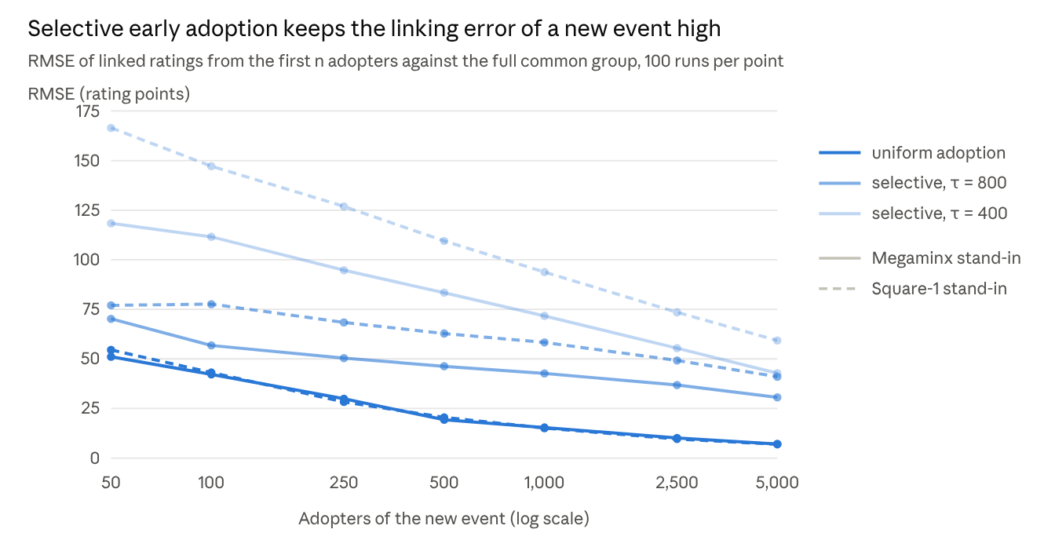
Figure 8. Root mean square error of linked ratings when the conversion of a new event is estimated from its first n adopters only, relative to the conversion from the full common group; Megaminx (21,079) and Square-1 (19,226) common groups as stand-ins, 100 runs per point, Monte Carlo standard error at most 4.1 points.
Under uniform adoption the error falls from 51–55 points at 50 adopters to 15 at 1,000 and 7 at 5,000. Under selective adoption it falls much more slowly: at 1,000 adopters it is 43–58 points for τ = 800 and 72–94 points for τ = 400, and at 5,000 adopters 31–41 and 43–59 points. Early adopters selected for strength form a common group that is faster at 3x3 than the eventual group, and the conversion depends on the composition of the common group (Table 1), so additional adopters of the same kind reduce the error little. The reference conversion is itself estimated from a self-selected group, so these values understate the error relative to a conversion for all potential adopters. Under a frozen base (Section 3.4) the conversion of a new event is fixed at the first renewal after its introduction, and the error at that moment carries over until the next renewal.

